May 2014

Child Advocates represented an all-time high of 928 clients in FY14, over 100 more than in FY13. Total clients represented annually had first grown above 600 in FY2000, above 700 in FY07 and then over 800 in FY10. Child Advocates will serve well over 1,000 clients in FY15. In FY13, clients range from infants through age 21; 10% are 0-2, 21% are 3-5 years, 31% are 6-12, 25% are teens and 13% are 18-21. The average length of representation is 2 years, 2 months. Child Advocates caseload is always slightly weighted towards girls, but close to half and half. The caseload has always been heavily African-American, 74% in FY13; we now represent more Latino clients than Caucasian, as well as a small number of clients who identify as mixed race, Asian, African and Caribbean.

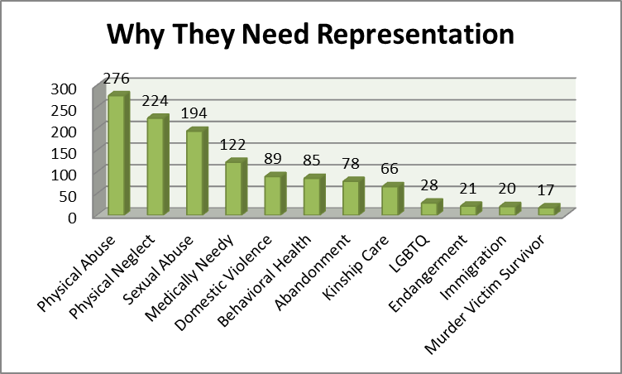

Children were referred to us for a variety of advocacy needs. Victims of abuse and neglect came from Dependent Court when Dependent petitions have been filed and criminal investigations may or may not be in progress, Criminal Court when charges have been filed, and from DR Court when abuse allegations surface in custody disputes. Dependent petitions may include reports of serious medical neglect, absence or inadequacy of parents, clients’ behavioral health needs that contribute to placement and school instability, truancy and other educational problems, and endangerment due to violence or abandonment. Dependent immigrant children were generally referred to Child Advocates from the Hebrew Immigrant Aid Society (HIAS) so that these clients can achieve Special Immigrant Juvenile Status pursuant to safety, permanency and legal immigrations status and green cards.

Children were referred from four main sources: Dependent Court, Criminal Court, Domestic Relations Court/Turning Points for Children and HIAS) As of FY10, the percentage of case referrals from Dependent Court has increased from 50-60% to 80% of the total, while case referrals from Criminal Court have decreased to around 13%. Immigration cases have been a steady but small number since they began in FY04. In FY13, Child Advocates represented clients in 748 Abuse and Neglect Proceedings; 120 child victims in Criminal Court, 31 clients in private custody matters, 25 clients with delinquency matters, and 27 children in Appeals we filed or responded to.

Child Advocates’ mission is “To advocate for victims of child abuse and neglect with the goal of securing safety, justice, well-being and a permanent, nurturing environment for every child.” Data suggests that we did quite well in accomplishing our mission in FY13. 86% of clients were considered safe when their cases closed. That would include older teens who left the system, as well as one multi-child family closed by a judge against Child Advocates' advice. That case reopened within a month, because children were not safe. In criminal cases where Child Advocates represented the child victims, referred because prosecutions were in serious danger of failing, 53% resulted in convictions, with all victims were accompanied to relevant hearings.

Well-being was defined as including health, behavioral health and education. 85% of clients had sustainable health insurance at the close of their cases, actually less successful than in the past few years, perhaps reflecting more unknowns in the face of changes in the insurance industry at that time. 94% of clients were receiving regular health care, and 93% were receiving regular dental care. Behavioral health outcomes were not calculated for this exact time period because of grant needs and reconstruction of this section of our database. However, for the three years ending in April of 2013, 87% of clients who were recommended for behavioral health treatment received it, and 85% of those clients showed improvements in behavioral health. 91% of clients were attending an appropriate school for their needs. For Special Education clients whose cases closed last year, 76% had their education needs met. For children aged three and under, 40% needed Early Intervention Assessment, 92% of those children received EI Assessments, and 91% of those received the services they needed.
In FY13, Child Advocates closed 92% of cases with our clients living in safe and nurturing permanent homes; since FY09, when we started keeping extensive outcomes data, that rate has been between 91% and 93%. Those clients who do not have permanent homes are all older teens who choose to end their court involvement and thus their services, as is their right. 30% of clients never left their family home, and more than 60% of clients were living with family members. A further success measure is that we achieved positive permanency outcomes for the clients in our Medically Needy project (i.e. children with serious medical and psychological problems that made permanency more elusive) at the same rate as for our overall caseload.

As called for in the strategic plan adopted by the Board of Directors in 2008, Child Advocates has been working to structure and fund reduced client caseloads for both our staff social workers and staff attorneys while increasing overall numbers of children represented. A time study conducted for that strategic planning process demonstrated that the caseload was then too high to fully implement the whole-child representation concept Child Advocates endorsed; i.e. advocating for each child’s needs in the realms of permanency, well-being, education and safety both in and out of court. Since then, Child Advocates has reduced the target full caseload for social workers to 60, and the target full caseload for staff attorneys to 30.

With a target static caseload of 60 at any one time, a full caseload social worker will handle from 80 to 105 children during a year, as cases close and new ones are appointed. A full caseload staff attorney with a static caseload of 30 will handle as many as 60 children during the year, along with all their other consulting and court coverage duties. Child Advocates was close to holding to these static targets until the second half of 2014, when caseloads overwhelmed the ideal. The City of Philadelphia requested a large increase in appointments of abuse and neglect cases; lengthy contract talks delayed hiring of sufficient new staff even as the agency increased intake to 334 new cases to make expanded year-end goals. Once the contract was signed, new social workers were quickly hired to return caseloads to target sizes.

Another agency strategy has been movement toward more specialization in order to meet the varied needs of our clients in different arenas, each with its own law, procedures and players. All four staff attorneys now specialize in a particular area of law in their own caseloads as well as providing in-depth consultation with other case handlers within the agency; these specialized areas include: Education, Medically Needy, Older Youth, and Domestic Relations. Three social workers now specialize as well, one in LGBTQ issues and two in Behavioral Health; these social workers provide consultation internally to other case handlers and trainings to outside professionals.

